**Topics: Confidence Intervals**

1. For each of the following statements, indicate whether it is True/False. If false, explain why.
2. The sample size of the survey should at least be a fixed percentage of the population size in order to produce representative results.

Ans: True.

1. The sampling frame is a list of every item that appears in a survey sample, including those that did not respond to questions.

Ans: False, because we can perform a survey only on the sample who has responded to the questions.

1. Larger surveys convey a more accurate impression of the population than smaller surveys.

Ans: False because surveys performed on smaller samples will give more accurate results and less time consuming and larger surveys also give accurate results similar to smaller surveys but is more time consuming.

1. *PC Magazine* asked all of its readers to participate in a survey of their satisfaction with different brands of electronics. In the 2004 survey, which was included in an issue of the magazine that year, more than 9000 readers rated the products on a scale from 1 to 10. The magazine reported that the average rating assigned by 225 readers to a Kodak compact digital camera was 7.5. For this product, identify the following:
2. The population

Ans: p = x/n = 225/9000 =0.025

1. The parameter of interest

Ans: mean, scale, sampling frame.

1. The sampling frame

Ans: 9000

1. The sample size

Ans: 225

1. The sampling design

Ans: Simple Random Sampling(SRS) technique

1. Any potential sources of bias or other problems with the survey or sample

Ans: Sample bias

1. For each of the following statements, indicate whether it is True/False. If false, explain why.
2. If the 95% confidence interval for the average purchase of customers at a department store is $50 to $110, then $100 is a plausible value for the population mean at this level of confidence.

Ans: False because when we normalize the data, it follows symmetrical bell-shaped curve and the population mean will be around $80.

1. If the 95% confidence interval for the number of moviegoers who purchase concessions is 30% to 45%, this means that fewer than half of all moviegoers purchase concessions.

Ans: True

1. The 95% Confidence-Interval for *μ* only applies if the sample data are nearly normally distributed.

Ans: True

1. What are the chances that 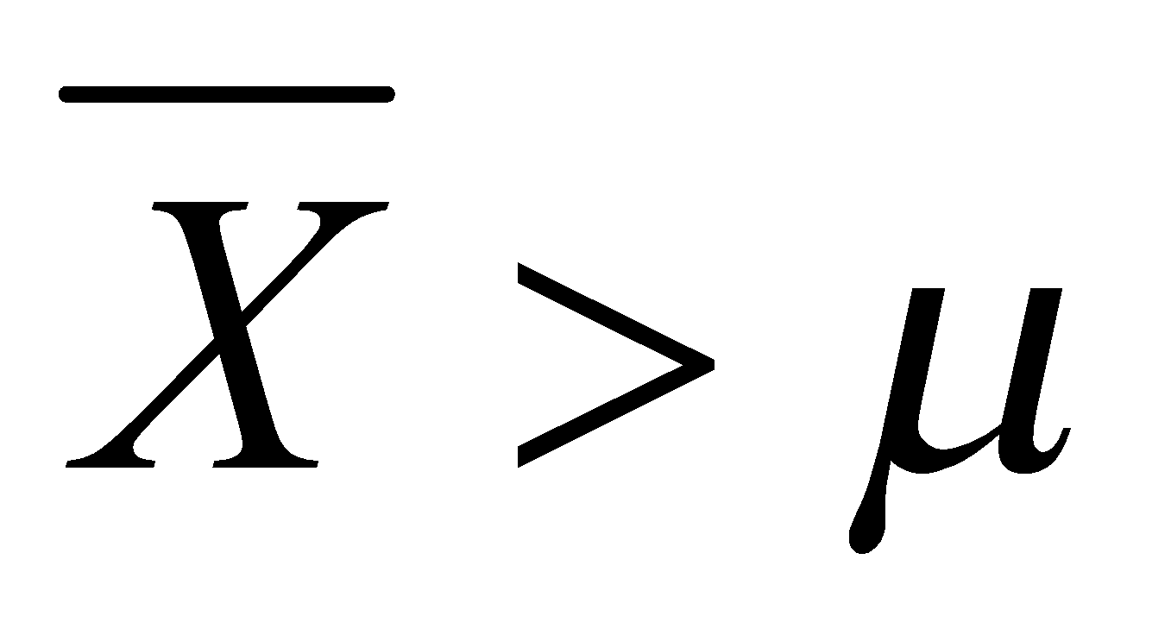?
2. ¼
3. ½
4. ¾
5. 1

Ans: D

1. In January 2005, a company that monitors Internet traffic (WebSideStory) reported that its sampling revealed that the Mozilla Firefox browser launched in 2004 had grabbed a 4.6% share of the market.
2. If the sample were based on 2,000 users, could Microsoft conclude that Mozilla has a less than 5% share of the market?

Ans: True.

1. WebSideStory claims that its sample includes all the daily Internet users. If that’s the case, then can Microsoft conclude that Mozilla has a less than 5% share of the market?

Ans: False because may be the internet users may also other browsers like Chrome, Yahoo etc.,

1. A book publisher monitors the size of shipments of its textbooks to university bookstores. For a sample of texts used at various schools, the 95% confidence interval for the size of the shipment was 250 ± 45 books. Which, if any, of the following interpretations of this interval are correct?
2. All shipments are between 205 and 295 books.
3. 95% of shipments are between 205 and 295 books.
4. The procedure that produced this interval generates ranges that hold the population mean for 95% of samples.
5. If we get another sample, then we can be 95% sure that the mean of this second sample is between 205 and 295.
6. We can be 95% confident that the range 160 to 340 holds the population mean.

Ans: B is correct

1. Which is shorter: a 95% *z*-interval or a 95% *t*-interval for *μ* if we know that σ =s?
2. The z-interval is shorter
3. The t-interval is shorter
4. Both are equal
5. We cannot say

Ans: We cannot say.

Questions 8 and 9 are based on the following: To prepare a report on the economy, analysts need to estimate the percentage of businesses that plan to hire additional employees in the next 60 days.

1. How many randomly selected employers (minimum number) must we contact in order to guarantee a margin of error of no more than 4% (at 95% confidence)?
2. 600
3. 400
4. 550
5. 1000

Ans: Population proportion, p = 0.5

Confidence level = 0.95

Significance level, α = 0.05

Z = Zα/2

Z = Z0.025

Z = 1.96

0.04 = 1.96√((0.5 * (1-0.5))/n)

n = (1.96*1.96) *0.5 *0.5/(0.04*0.04)

n = 600.

1. Suppose we want the above margin of error to be based on a 98% confidence level. What sample size (minimum) must we now use?
2. 1000
3. 757
4. 848
5. 543

Ans: (2.33)^(2) * 0.2(0.2)/(0.02)^(2)

=5.4289*0.04/0.0004

=542.89

So therefore, the answer is option D.